**SOFTWARE REQUIREMENTS SPECIFICATION**

For

**Prepared By:-**

Deepan R 721220104006

Kesavan E 721220104017

Sathish N 721220104043

Suresh Kumar 721220104043

**Academic Year : 2023-2024**

Department of Computer Science and Engineering

**1.INTRODUCTION**

**1.1 Purpose:**

The primary purposes of an e-commerce website. An e-commerce website serves several purposes, all geared towards facilitating online buying and selling transactions. These purposes can vary depending on the specific goals and business model of the e-commerce platform.

**1.2 Scope of Development Project:**

**1.2.1 User Accounts and Profiles:**

Define user account features, such as registration, login, profile management, and order history.

**1.2.2 Design and User Interface:**

Describe the desired design aesthetic and user interface. Consider factors such as branding, color schemes, layout, and overall user experience.

**1.2.3 Content and Product Information:**

Specify the types of content that will be included on the website, such as product descriptions, images, pricing, and any additional information.

**1.2.4 Payment and Security:**

Detail the payment methods the website will support and outline security measures to protect customer data

**1.2.5 Mobile Responsiveness:**

Determine whether the website should be responsive for mobile devices and, if necessary, detail any specific mobile features.

**1.2.6 Analytics and Reporting:**

Describe the analytics tools and reporting mechanisms that will be integrated into the website for monitoring performance and user behavior.

**1.2.7 Marketing and Promotion:**

Outline any marketing and promotional features, such as discount codes, email marketing integration, and social media sharing options.

**1.2.8 Compliance and Legal Considerations:**

Address legal requirements, such as privacy policies, terms and conditions, and compliance with data protection regulations.

**1.2.9 Testing and Quality Assurance:**

Define the testing procedures and quality assurance processes to ensure the website functions correctly and is free of bugs.

**1.3 Definitions, Acronyms and Abbreviations**

JAVA -> Platform Independent

SQL -> Structure Qurey Language

HTML -> Hyper Text Markup Language

CSS -> Cascading Style Sheet

ER -> Entity Relation

UML -> Unified Modeling Language

IDE -> Integrated Development Environment

**1.4 Reference:**

1. Book
2. "E-commerce 2021" by Kenneth C. Laudon and Carol Traver - This book provides a comprehensive overview of e-commerce concepts, strategies, and technologies, making it a valuable resource for understanding the fundamentals of e-commerce.

2. "Web Development and Design Foundations with HTML5" by Terry Felke-Morris - For those involved in the technical aspects of web development, this book offers a strong foundation in HTML5, CSS, and web design principles.

1. Web Site
2. W3Schools (***https://www.w3schools.com/***) - A comprehensive resource for learning web development languages like HTML, CSS, JavaScript, and more.
3. Google Developers (***https://developers.google.com/web***) - Provides resources and best practices for web development, including mobile optimization and progressive web apps

**2. OverAll Descriptions:** **2.1 Product Prespective:**

Use Case Diagram for E-Commerce Website

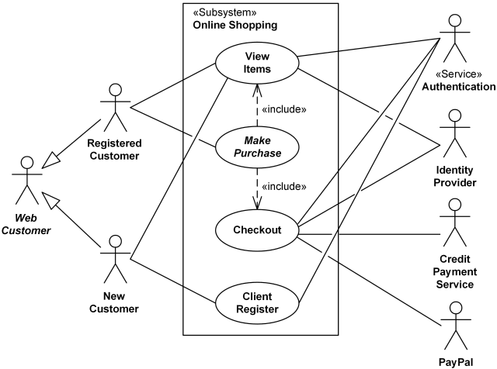

A use case diagram for an e-commerce website illustrates the interactions between users (actors) and the various functions or features (use cases) of the website. Here's a simplified use case diagram for an e-commerce website

**2.2 Product Function:**

Entity Relationship Diagram for E- Commerce Website

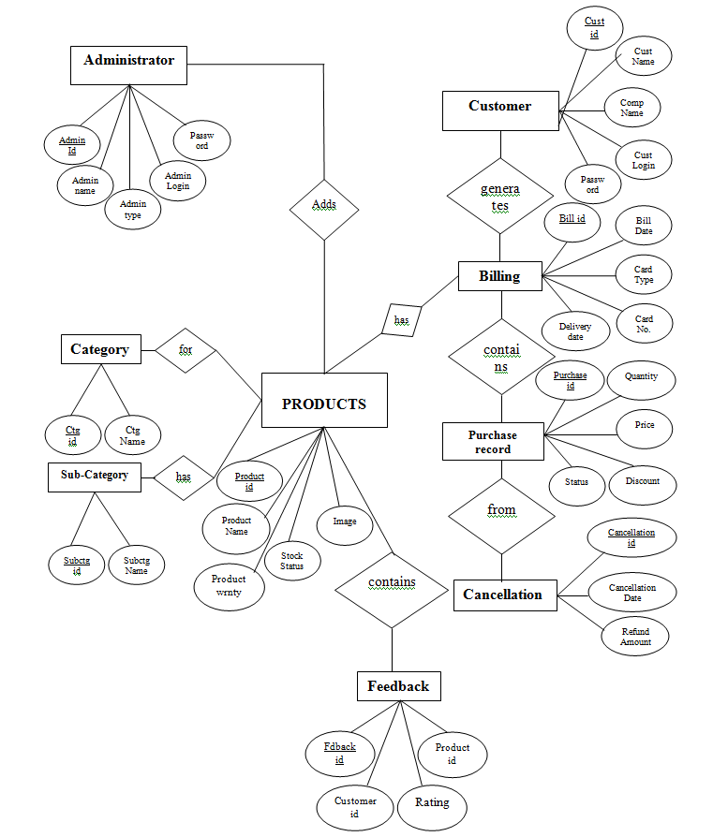

Creating an Entity-Relationship Diagram (ERD) for an e-commerce website can be complex and highly dependent on the specific requirements and functionalities of the website. However, I can provide you with a simplified ERD that represents some of the core entities and relationships commonly found in e-commerce systems. Please note that this is a basic example, and real-world e-commerce systems often involve many more entities and relationships.

**2.3 User Classes and Characteritic:**

In the context of an e-commerce website, user classes or user personas help in understanding and designing for the various types of users who interact with the platform. Each user class has distinct characteristics and requirements. Here are some common user classes and their characteristics for an e-commerce website:

1.Shoppers:

1. Characteristics:

* Browse products and categories.
* Add items to the shopping cart.
* Proceed to checkout.
* Make purchases.
* View order history.

1. Needs:

* Easy navigation to find products.
* Clear product descriptions and images.
* Secure payment options.
* Order tracking and delivery updates.

2.Registered Users:

1. Characteristics:

* Create and manage user accounts.
* Save shipping and payment information.
* Maintain wishlists.
* Leave product reviews and ratings.

3.Guest Shoppers:

1. Characteristics:

* Shop without creating an account.
* Provide minimal information at checkout.

**2.4 Operational Environment:**

The operational environment for an e-commerce website refers to the infrastructure, software, processes, and external factors that collectively support the functioning of the website. Building and maintaining a robust operational environment is crucial for ensuring the website's reliability, performance, security, and scalability. Here are key components of the operational environment for an e-commerce website

**2.5 Assumption and Dependencies:**

**Assumption for Ecommmerce:**

* **Internet Access**: Users have reliable internet access to browse and make purchases on the website.
* **Device Compatibility**: Users will access the website from various devices, including desktops, laptops, tablets, and smartphones.
* **Payment Methods**: Customers have access to the payment methods you plan to offer, such as credit/debit cards, digital wallets, or other forms of online payment.
* **Product Availability**: Products displayed on the website are assumed to be in stock or available for purchase unless otherwise stated.

**Dependencies for Ecommmerce:**

* **Payment Gateway**: You depend on a payment gateway provider to process transactions securely.
* **Web Hosting**: The website relies on a web hosting service for server infrastructure and uptime.
* **Inventory Management System**: If you sell physical products, you depend on an inventory management system to track stock levels.

**2.6 Data Requirement:**

The data requirements for an e-commerce website will vary depending on the specific features and functionality of the website. However, some common data requirements include:

* **Product information**: This includes the product name, description, images, price, and other relevant details.
* **Customer information**: This includes the customer's name, email address, shipping address, billing address, and other relevant details.
* **Order information**: This includes the order date, order number, shipping method, payment method, and other relevant details.

**3**.**External Interface Requirement:**

**3.1 GUI**

The external interface requirements for a GUI (graphical user interface) for an e-commerce website will vary depending on the specific features and functionality of the website.

* **A user-friendly and intuitive design**: The GUI should be easy to use and navigate, even for users who are not familiar with e-commerce websites.
* **A clear and concise layout**: The GUI should be well-organized and easy to understand. All important elements, such as the product catalog, shopping cart, and checkout process, should be clearly visible and easy to access.
* **A consistent look and feel**: The GUI should have a consistent look and feel across all pages of the website. This will help to create a sense of familiarity and trust for users.
* **Responsive design**: The GUI should be responsive and adapt to different screen sizes and devices. This will allow users to shop on the website using any device, such as a desktop computer, laptop, tablet, or smartphone.

**4.System Features:**

System features for an e-commerce website are critical for creating a robust and user-friendly online shopping experience. Here's a comprehensive list of features commonly found in e-commerce websites:

**Product Catalog:**

* Display products with detailed descriptions, images, and prices.
* Organize products into categories and subcategories.
* Enable product search and filtering options.

**Product Search and Navigation**:

* Implement a powerful search engine with filters.
* Faceted search for refining results by attributes (e.g., size, color).
* Bread-crumb navigation for easy browsing.

**User Registration and Profiles**:

* User account creation and management.
* Profile customization and address management.
* Wishlist and favorites for saving products.

**Shopping Cart:**

* Add and remove items from the cart.
* Display cart summary, including quantities and total price.
* Save cart contents for future sessions.

**5.Other Non-Functional Requirement:**

Non-functional requirements in an e-commerce website are just as crucial as functional features. These requirements focus on the characteristics, qualities, and constraints that shape the overall user experience and system behavior.:

**Performance:**

* **Response Time**: Specify maximum acceptable response times for various website operations (e.g., page load, search, checkout).
* **Scalability**: Define how the system should handle increased traffic, especially during peak seasons or sales events.
* **Load Testing**: Conduct load testing to ensure the website can handle expected loads without performance degradation.

**Reliability and Availability:**

* **Uptime Requirements**: Specify the desired uptime percentage (e.g., 99.9%) and any planned maintenance windows.
* **Failover and Redundancy**: Ensure high availability through redundant servers, load balancers, and failover mechanisms.

**Scalability and Capacity Planning:**

* Determine how the system will handle growth in terms of user base, product catalog size, and traffic.
* Plan for horizontal and vertical scalability of infrastructure components.

**Usability and Accessibility**:

* Ensure the website is user-friendly and easy to navigate.

**6.Other Requirement**

**6.1 Data and category Requirement:**

**1.Product categories**: E-commerce websites typically organize their products into categories, such as clothing, electronics, home goods, and so on. This helps customers to find the products that they are looking for more easily.

**2.Subcategories**: E-commerce websites may also further divide their product categories into subcategories. For example, the clothing category might be divided into subcategories such as men's clothing, women's clothing, and children's clothing.

**3.Attributes:** E-commerce websites may also use attributes to further describe their products. For example, a clothing product might have attributes such as size, color, and material.

**6.2 Class Digram**

A class diagram is a visual representation of class objects in a model system, categorized by class types. Each class type is represented as a rectangle with three compartments for the class name, attributes, and operations.

